**ANALYSIS OF A 4-YEAR SALES DATA: OPERATION INCREASE SALES AND PROFIT**

PROBLEM STATEMENT:

A United States retail company wants to analyze sales data to generate insights for their growth. The company wants to know the most profitable region and the product categories that generate the most profit.

As a data analyst in the company, you have been tasked with working on this project. You have identified the data you need, asked the right questions, and collected the dataset.

MISSION:

1. Identify Key variables in the data that affects sales and profits.
2. Analyze the provided four years data and draw insights from it.
3. Provide recommendations to the company based on analyzed data to enable them take data driven decisions to improve sales.

PROCEDURE:

1. Load Dataset / transform data
2. Analyzing Tables & Relations
3. Data Cleaning - Power Query Editor:- DAX
4. Developing model
5. Creating Interactive Dashboard / Report

INSIGHTS FROM THE GRAPH

1. **West Region** has the most recorded sales and profits

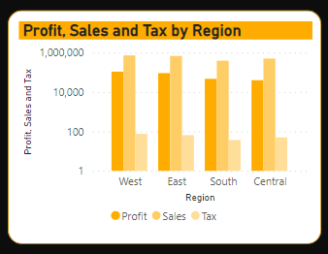

1. Most of the sales were recorded in **California**. More products should be sold there to yield more profit.

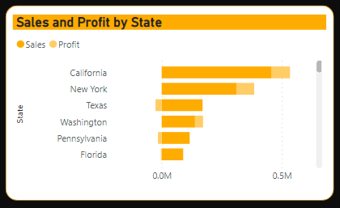

1. Based on the product category analysis, **Technology** and **Furniture** had more sales in the West Region compared to Office Supplies.

﻿ ﻿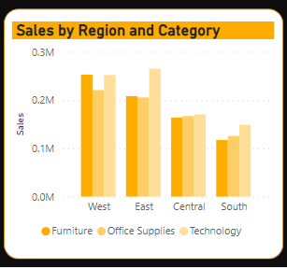

1. In 2014, there was **increase** in the trend of **sales**.

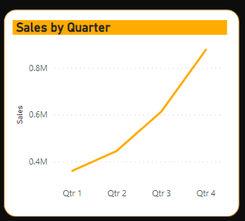

RECOMMENDATIONS:

1. Increase the advertisement of products in the regions & States of low sales. This will improve the sales and profit since they are positive correlated.
2. Engage in market research, specifically in areas where sales have been low, to find out competitors and what products are acceptable.